**5.2 - REST - Get country based on country code**

Steps to perform implementation of Getting country based on country code.

**Step1**: Make sure to create country.xml so it contains the countries and list.

i.e., country.xml

|  |
| --- |
| <?xml version="1.0" encoding="UTF-8"?>  <beans xmlns="http://www.springframework.org/schema/beans"  xmlns:xsi="http://www.w3.org/2001/XMLSchema-instance"  xsi:schemaLocation="  http://www.springframework.org/schema/beans  http://www.springframework.org/schema/beans/spring-beans.xsd">  <bean id="in" class="com.cognizant.spring_learn.Country">  <property name="code" value="IN" />  <property name="name" value="India" />  </bean>  <bean id="us" class="com.cognizant.spring_learn.Country">  <property name="code" value="US" />  <property name="name" value="United States" />  </bean>  <bean id="de" class="com.cognizant.spring_learn.Country">  <property name="code" value="DE" />  <property name="name" value="Germany" />  </bean>  <bean id="jp" class="com.cognizant.spring_learn.Country">  <property name="code" value="JP" />  <property name="name" value="Japan" />  </bean>  <bean id="countryList" class="java.util.ArrayList">  <constructor-arg>  <list>  <ref bean="in" />  <ref bean="us" />  <ref bean="de" />  <ref bean="jp" />  </list>  </constructor-arg>  </bean>  </beans> |

**Step2**: Create a Model class.

i.e.,Country.java

|  |
| --- |
| package com.cognizant.spring_learn;  public class Country {  private String code;  private String name;  public Country() {}  public Country(String code, String name) {  this.code = code;  this.name = name;  }  public String getCode() {  return code;  }  public void setCode(String code) {  this.code = code;  }  public String getName() {  return name;  }  public void setName(String name) {  this.name = name;  }  @Override  public String toString() {  return "Country [code=" + code + ", name=" + name + "]";  }  } |

**Step3**: Create a service layer.

i.e., CountryService.java

|  |
| --- |
| package com.cognizant.spring_learn.service;  import java.util.List;  import org.springframework.context.ApplicationContext;  import org.springframework.context.support.ClassPathXmlApplicationContext;  import org.springframework.stereotype.Service;  import com.cognizant.spring_learn.Country;  @Service  public class CountryService {  public Country getCountry(String code) {  ApplicationContext context = new ClassPathXmlApplicationContext("country.xml");  @SuppressWarnings("unchecked")  List<Country> countries = (List<Country>) context.getBean("countryList");  return countries.stream()  .filter(country -> country.getCode().equalsIgnoreCase(code))  .findFirst()  .orElseThrow(() -> new CountryNotFoundException("Country code not found: " + code));  }  } |

**Step4**: Create a Custome Exception i.e.,

CountryNotFoundException.java

|  |
| --- |
| package com.cognizant.spring_learn.service;  public class CountryNotFoundException extends RuntimeException {  public CountryNotFoundException(String message) {  super(message);  }  } |

Step5: Create a Controller layer.

i.e., CountryController.java

|  |
| --- |
| package com.cognizant.spring_learn.controller;  import org.springframework.beans.factory.annotation.Autowired;  import org.springframework.web.bind.annotation.*;  import com.cognizant.spring_learn.Country;  import com.cognizant.spring_learn.service.CountryService;  @RestController  public class CountryController {  @Autowired  private CountryService countryService;  @GetMapping("/countries/{code}")  public Country getCountry(@PathVariable String code) {  return countryService.getCountry(code);  }  } |

**Step6**: Create Main App.

i.e., SpringLearnApplication.java

|  |
| --- |
| package com.cognizant.spring_learn;  import org.springframework.boot.SpringApplication;  import org.springframework.boot.autoconfigure.SpringBootApplication;  @SpringBootApplication  public class SpringLearnApplication {  public static void main(String[] args) {  SpringApplication.run(SpringLearnApplication.class, args);  }  } |

Step7: Add the required dependencies in the pom.xml

|  |
| --- |
| <dependency>  <groupId>org.springframework.boot</groupId>  <artifactId>spring-boot-starter-web</artifactId>  </dependency> |

**Step8:** run the application

**Expected Output:**

When I run in the browser

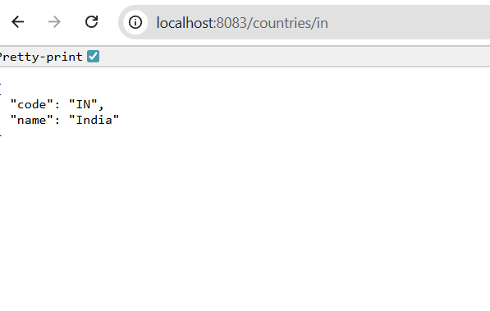

**Step9:** Testing through Postman.

Create a new Get HTTP requet.

Enter URL

i.e., <http://localhost:8083/countries/us>

the Json in body is,

